**Model A – Name and Surnames:**

Given a database name “inventions”, do the following SQL database managements and queries. Having the same result in the query does not guarantee a total query correctness.

1. Design a function name ‘getfirstinvention’, which display the name of the first invention, the year of the invention, its description, and the name of the person who did it. [1.75 points]

Write the call to the function to get the result below [0.25 points]

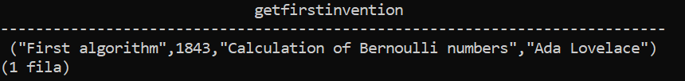

1. Design a function name ‘getinventorscentre’, which displays the name of those inventors who studied in a specific centre given as a parameter, and also their occupation. Moreover, it has to be taken into account that if the name of the centre provided does not exist in the database an error has to come up. [1.75 points]

Write the call to the function to get the result below [0.25 points]

For instance, if the name of the centre provided is ‘MIT, then the result is as follows:

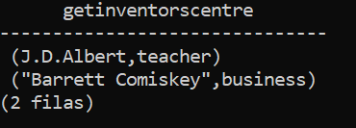

For instance, if the name of the centre does not exist such as ‘Stanford’, then the result is as follows:



1. Design a procedure to display the name of those inventions created between an interval of years [year1, year2], provided as parameters, the year of the invention, and the name of the inventors. [1.75 points]

Write call to the procedure to display the information required. [0.25 points]

For instance, if the years provided are 1980 and 2000, the result is as follows:

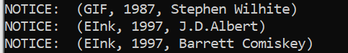

1. Every time an insert, update or delete operations are performed on the table ‘inventor’, it is required their registration. For this purpose, a table name ‘operation_inventor_log’ has to be created with the following fields: [0.25 points]

|  |  |
| --- | --- |
| **Table:**  **operation_inventor_log** | |
| **Attribute** | **Type** |
| **operation** | **char(1)** |
| **stamp** | **timestamp** |
| **inventor_name** | **varchar(50)** |
| **occupation** | **varchar(100)** |

1. Create a trigger that every time an inventor is created, updated or deleted, a message has to come up. [1.5 points]
2. Test the trigger doing the following steps: [0.75 points]
3. Insert data about the following inventor: [0.25 points]

Name: ‘Tim Berners Lee’; Birth place: ‘London’; Birth year: 1955; occupation: ‘Computer Science scientist’

1. Modify the occupation to ‘Computer scientist’ [0.25 points]
2. Delete ‘Tim Berners Lee’ from the inventor table. [0.25 points]

Finally, check that the three operations have been done in the table ‘operation_inventor_log’, and place here a capture of the screen where the result is shown (below you can see an example).

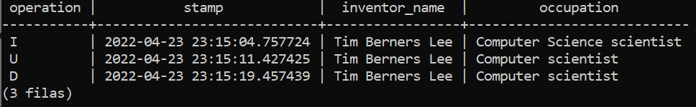

1. 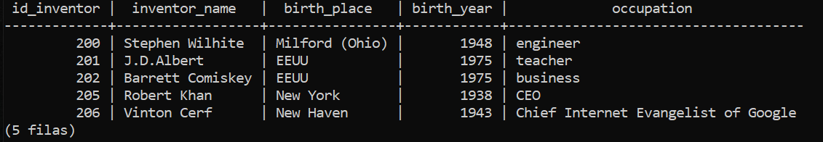Display the information of all those inventors where all their inventions have an invention year higher than 1945. (division) [1.5 points]